24/7 ONLINE MART

Feasibility Report

Nabeel Siddiqui

Wali Ullah

Shahzaib Gauhar

**Table of Contents**

**Survey Questions 2**

**Executive Summary 3**

**Team Members Information 3**

**Preliminary Requirement Analysis 4**

**Suggested Deliverables 6**

**Process to be followed 7**

**Outline Plan 8**

**Visibility Plan 10**

**Business Consideration 11**

**Risk Analysis 12**

**Technical Requirements 13**

**Conclusion 14**

**24/7 Online Mart For Xyz Company**

**Feasibility Report**

1. **SURVEY QUESTIONS (Time Required: 15 min)**

**Note: Please give a one(1) line answer and try to give to the point answer, Thankyou.**

1. What will be the impact on the organization’s(client) business if the this service didn’t work?
2. What is the future improvement/optimization if the client’s orgranizations hand over the software product to its developers.
3. What happen if the software(market, idea) doesn’t work in urban areas?
4. How urban people going to purchase goods as of urban’s economical condition is not gooa at all, in this condition what our criteria to sold goods?
5. Is there any existing similar software available? If available then how you can differenciat it with your?
6. How often you purchased goods online especially groceries?
7. What is the difference between price of online shopping as compared to physical shopping?
8. How much trust do you have on online shopping?
9. What is the best online shopping services in your opinions or experience?
10. What is your trust level to given your personal phone number, cnic number and your home address for our software product?
11. For what method of payment you’re comfortable? A COD(cash on dilevery or debit/credit card?)
12. If our service don’t offer any coupon or bonus on any product would you still purchase/shopped?
13. What feature you would like to see/wish most in our software that enhance our software?
14. Would you prefer a mobile application software or web application? What is most convenient to suit your portability?
15. What is your thought about of hours products shipping and 24/7 availability?
16. What is your opinion about existing qaulity packaging techniques or experince?
17. Please share your most recent online shopping experience in a one line answer.
18. What type of discount you would like to see in our future service? In coupon form, overall discount or more extra pts(in the result of purchased item!)?
19. What feature you most dislike in your favourite online shopping application?
20. What is opinion on our idea of 24/7 availability, E-Wallet points?
21. According to your perspective, what is the most important thing which can success the business growth of an online shopping?
22. If you developed your own online shopping service what most top feature or relieve you offer to your customers?
23. How would you like us to develop the application?
24. What are your goals/desires?
25. How often do you use a "specific feature" or vice versa?
26. Do you like the changes/updates in the app design?
27. Is there any function/feature you'd like us to add?
28. Is our app helping you achieve your goal?
29. How would you rate our update/application?
30. How much did you practice spend on online marketing last year?
31. Do you develop a detailed online marketing budget price start of the each year?
32. Does the online marketing products are well satisfied ?
33. Are all the online products are under range of your budget?
34. should you prefer online marketing over a daily common marketing?
35. Did you agree that online marketing is more less time consuming and easy to handle?
36. **EXECUTIVE SUMMARY**

The following proposed system has been developed for the reference staff of XYZ Limited, a recently established e-commerce store with a desire to extend its services to Pakistan. The reference staff clients will be represented by Senior Developer Mr. Robert Brewster. Mr. Robert drafted the original client proposal and has effectively managed to convey the key points of the organization’s need and scope. Ms. Lucy Williams from XYZ company serves as an honorable participant of the project. The basic goals of the project are to provide a simple yet super interactive e-commerce application for the XYZ super market store. The idea is to transform the traditional ways of marketing to highly interactive and user-friendly e-commerce site to automate and streamline the processes involved in the operation of the super market. The application facilitates easy interaction with the store through a smartphone anywhere, accompanied by secure transactional and online-shopping features, especially in the rural areas where the facility is quite rare and inefficient. The application aims to be extremely helpful in fostering self-management capabilities with advanced data organization.

1. **STUDENT INFORMATION**

**Nabeel Siddique (Project Leader)**

**Student ID: 14682**

**Email:** [**Nabeel.14682@iqra.edu.pk**](mailto:Nabeel.14682@iqra.edu.pk)

**Name: Wali Ullah**

**Student ID: 42318**

**Email:** [**Wali.42318@iqra.edu.pk**](mailto:Wali.42318@iqra.edu.pk)

**Name: Shahzaib Gauhar Khan**

**Student ID: 14944**

**Email:** [**Shahzaib.14944@iqra.edu.pk**](mailto:Shahzaib.14944@iqra.edu.pk)

1. **PRELIMINARY REQUIREMENTS ANALYSIS**

* **Application Overview**

**Objectives:**

The core objective is to transform the store services to a fully-function e-commerce store. To provide a platform which supports real-time buying, secure payment and quick delivery facility.

**Business Objectives:**

The project aims to cut the cost of the man power and resources which incurs to handle huge influx of data. The project may help improve customer service and interaction, employee and data management and target marketing through marketing tools on the technical level. It may enhance customer feasibility through an interactive UI; neatly managed categories, types and costs of the products with advanced searching and marketing features. One of the goals is to strengthen its services in the rural areas, mainly delivery and availability service.

**Current Business Operations:**

* Currently the store maintains a record manually on paper.
* Store staff is responsible to provide all the services such as payment collection, customer dealing, and item sorting and documentation.
* Since the store lacks an item delivery service, the store entertains a very limited amount of audience.

**User Roles and Responsibilities:**

**Admin Roles**

* To modify, reject, approve user order.
* To ban, approve, delete user accounts.
* To monitor user feedbacks, comments and activities where needed.
* To update existing products, or add/remove the existing product.

**User Roles**

* Browse items, manage shopping cart, place item order.
* Make payments.
* Leave reviews, comments.

**Interactions with Other Systems:**

The e-commerce site will be developed from the scratch; therefore, it will not interact directly with any other platform or system. However, previous sales records and transactions might become the part of the system after a certain duration.

**Product Rollout Considerations:**

The design and development of database, UI and the services are expected to be carried out in a phased manner over two months before the system is tested and put into operation.

* **Functional Requirements**

**Statement of Functionality:**

This software system will be flexible and sustainable with a user interface for ordering and making payments.

* This software will consist of multiple roles for members, such as administrator and the user. Each role will be assigned different view and functions.
* At a time, any user can access the store with their smartphones.
* The search function will be able to fetch accurate results for the users.
* Login system for secure user access.
* Administrator abilities to flush out unwanted users and/or reviews/comments.
* Checkout form, feedback/review form, cart function and product add/remove/update functions.

**Non-functional Requirements:**

The software will require a smartphone powered by android® OS.

Requires a stable internet connection.

The application needs a proper functional device to use anytime and anywhere.

The criteria for success of the system would be measured by the flexibility and sustainability of the system. The functionality and ability of the system to meet all requirements (i.e. simultaneous access from different all the phones, effectiveness of the design of the central data server, automatic backups, various levels of user access, server load management etc.) would be critical for success as well. Ease of use and efficiency would be adequate measures of performance; after a week of training and testing, the users should be able to use the system effectively.

**Optional Features:**

User may be able to apply discount codes.

Optional window shopping feature.

Bonus points after every purchased.

**Usability:**

Usability issues such as speed of operation for the user interface, collection and storage of important quantitative data, speed and efficiency of the work flow processes through automation, and concurrency of collected data will be important considerations.

**Scope:**

All transactions would be handled electronically or online – e-commerce facilitates all the various shopping-related activities, including the purchase and sales of goods and services, shipping, billing, etc. online.

1. **SUGGESTED DELIVERABLES**

|  |  |  |
| --- | --- | --- |
| **Elapsed time since start of the project** | **Milestone** | **Deliverable** |
| Week 01 | Planning. | 8/16/2020 |
| Week 02 | Systems Analysis and Requirements. | 8/23/2020 |
| Week 03 | Systems Design. | 8/30/2020 |
| Week 04 | Development. | 9/6/2020 |
| Week 05 | Integration and Testing. | 9/13/2020 |
| Week 06 | Implementation. | 9/20/2020 |
| Week 07 | Operations and Maintenance. | 9/27/2020 |

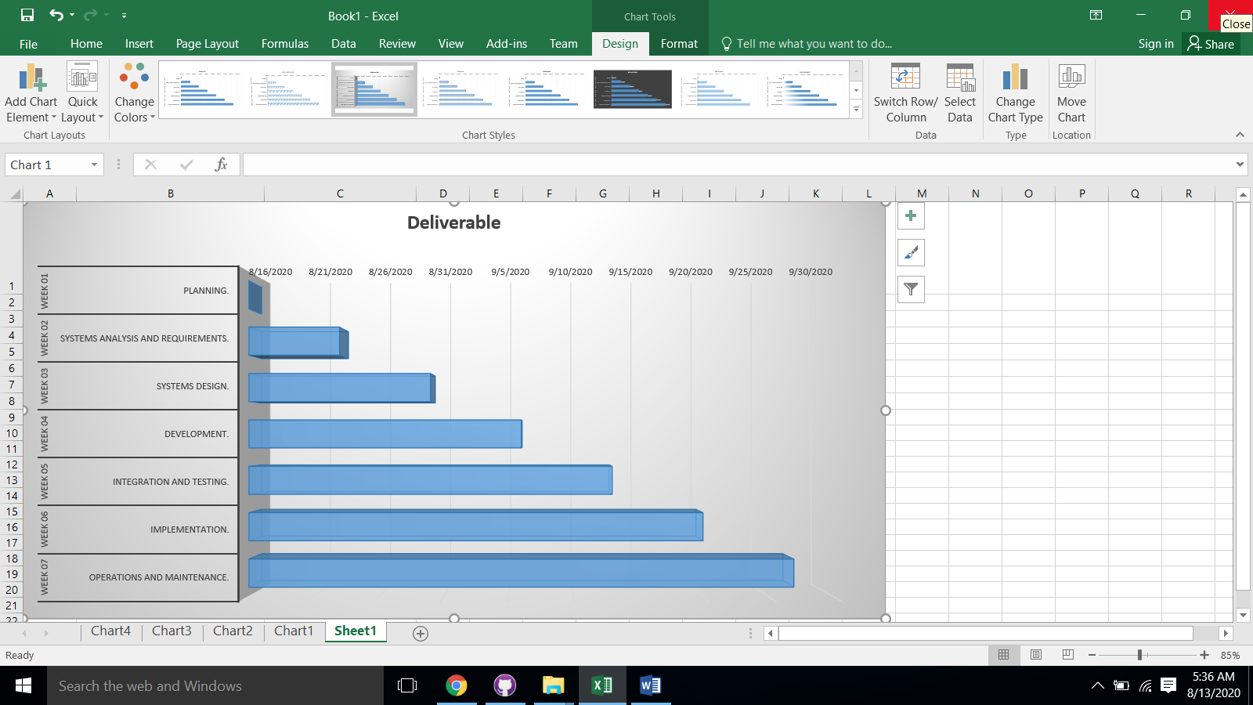

1. **Process to be followed**

**Discription:**

We use the iterative refinement with the agile development process to achieve this project requirement’s. We choose this method because our client’s is our first priority, we almost know the enough requirements that in the further future processes there is a very minimum risk that our client’s change project requirements.

We use the concept of agile development process to implement the sprint approach, and as the our users is the first priority we follow the rapid prototyping, feedback and iteraction by using iterative refinements.

**Benefits:**

1. **Parallel Working and Sprint Approach:**

By work parallel each task our team can achieve this project fast and on time with our client’s satisfaction.

We implement the sprint approach so our team can achieve the desired product under the specific time and deadline to over the time constraints and to deliver the product on time.

1. **Rapid Prototyping:**

By conduct the weekly session and present the early sketch, paper and digital prototyping we achieve the user interation and study it and analyse the feedback to better understand the requirements at the early phase.

1. **Outline Plan**

**Discription:**

As we use iterative development, we present the initial prototype and mockup to our client’s so that our clients can interact with the prototype and give it’s valuable feedback’s.

**Iterations:**

1. **System Analysis and Requirement Gathering**

Final Delivered Milestone: 8/23/2020

**Discription:**

Initial Phase (from 16 to 19 August)

In this phase we gathering the requirements from our clients and clear all the ambiguities and hand over the initial report to our clients.

Final Phase (from 19 to 23 August)

For the final phase we added the presentation phase delivered by our team members and confirmed all the requirements.

1. **System Design**

Final Delivered Milestone: 8/30/2020

**Discription:**

Initial Phase (from 23 to 25 August)

Initial sketch and paper prototype and make a summary report of the clients interaction

Final Phase (from 25 to 27 August)

Initial digital prototype and make a summary report of the clients interaction

Final Phase (from 27 to 30 August)

Final digital prototype and presentation phase and a reference material how to interact with it and what is the features and make a user experience report

1. **Development**

Final Delivered Milestone: 9/6/2020

**Discription:**

Initial Phase (from 30 August to 1 September)

In this phase we deliver the native prototyped experienced to our clients and take feedback’s.

Initial Phase (from 1 to 3 September)

Until this phase we work on our database to add all the functionality like data tables, users session’s, signIn/signOut, Add to cart functionality and the Bonus point e-wallet and alot other functions.

Initial Phase (from 3 to 4 September)

Until this we should completed the payment gateway functionality and done the final report and simple manual(for the potentials users and our client’s) for the presentation and prepare for the testing phase.

Final Phase (from 4 to 6 September)

Present the report and start the testing phase

1. **Integration and Testing**

Final Delivered Milestone: 9/13/2020

**Discription:**

Final phase (from 6 to 13)

On this phase our team should debug and test all the features and functionality and should ready to pass the acceptance test for the final software product.

1. **Final Software Product**

Final Delivered Milestone: 9/20/2020

**Discription:**

Until this we deliver the final product, source code and conduct the final presentation to our client’s for the final milestone.

1. **Visibility plan**

**Discription:**

As we mention early that our clients is our first priority that’s why we use iterative refinement and agile development.

**External:**

**Communication with client’s**

By using iterative refinement method we conduct a small weekly interaction between our team and our clients to ensure the progress and to satisfy our clients requirments.

In weekly meetings/interaction we also generate and hand over the copies of our weekly progress to our client’s by doing this we ensure that every work is going up to mark.

In a small report that we our going to show our clients includes dummy prototypes, mockups to achieve the surety that what we our doing is right.

**Internal:**

**Communication with Team:**

1. **Casual Interaction:**

For the team communication we arranged our weekly meeting through Zoom(Suitable and reliable medium in covid 19) and for reminders we use telegram mobile application

1. **Formal Team Interaction:**

For the most formal and project implementation process we use github software(desktop Application and Website Application).

**Formal Deliverables and Milestone:**

**Live Demonstration:**

We give a online demonstration to our clients on a weekly bases, we choose a online option because our clients is live on another country.

**Presentation:**

After every week we report every progress that we make which includes our milestones and mini dilerables.

**Report Feedback:**

By giving report to our clients we records all the feedback from our respective clients and work on it to iteratively to achieve a desired product.

1. **Business Consideration:**

**Solution:**

Possible consideration’s that might be a concern includes:

1. **USE OF A USER PRIVATE DATA:**

**Discription:**

All the user important and private data like debit/credit card, other third party payment gateway, address, password and other valuable information is securely protected by the online cloud realtime database.

1. **Payment Security:**

**Discription:**

Currently our client’s main focus to process online payment gateway is through a secure third party service like easypaisa so there is no concern about the security of payment currently.

But if the user demands to add the credit/debit card payment functionality we can fulfilled the user requirements by using the extremely secure serverless realtime database which is iso certified and enforced by server-side rules.

1. **Copyrights, Trademark and Patents:**

**Discription:**

**Priliminary Agreement:**

Our team “DevOps47” intends to give our clients company a limited license to use and modify the software sytem.

Our team will not be responsible once the system is delivered to our client.

Our team doesn’t plan to trademark any names in relation to the software system, so trademark are not foreseen as being an issue.

Currently the software that we build doesn’t have any parts of patent application. later if the situation arises, the team reserves the rights to the patented parts while the client’s have full rights to use and can modify un-patented part.

1. **Risk analysis**

**Solution:**

These following points which is proposed by our team after reviewed the client requirements isn’t the entirely risk free, we do our utmost effort to minimize the following risks with the satisfaction of our client’s.

1. **Short period of time:**

**Discription:**

Our client demands us to complete this software in almost 2 months and during this we already have an limited time because of this pandamic situation which leads us to limited interaction with our team and client’s and the non pyshical meetings and interviews.

**Solution:**

As the time concern we use split our tasks and do parallel work with the client feedback to overcome the time constraint and for the interaction we do weekly online interation and surveys on different platform to fill the gab between our clients and our team.

1. **Resources:**

**Discription:**

We have the limited hardware resources which will be the major concern about our implementation of the software on the expectation of our client’s.

About 40% of our team member operate this task from their home where proper hardware and the other electricity constraints has the problem which we have to tackle with.

Since other software and database is free of cost so we don’t need to think about software costs.

There is also other concerns as well which includes software failure, data lose, hardware failure due to short circuit which waste our time and might delay our project.

**Solution:**

We divide our work remotely using the github so incase of hardware failure and data lose we have our backup available on github repository.

And for the limited hardware we will going to assign the implementation task to most senior and experience which have the required hardware available.

1. **In Experience staff(limited knowlegde/less experience):**

**Discription:**

As a small group team we have an in experience members who have an limited knowledge and less experience.

**Solution:**

By using the parallel working and rapid prototyping and feedback which is iterative development method we learn and adapt the all the technicality and with the supervision of the experience developers and members we overcome all the limitation’s!

1. **Requirements Changing and Future scope:**

**Discription:**

Due to the limited scope of the project we will design the software according which result that for e.g: we will be using the free trial of the online database which support the concurrent users at the same time but in near future if the business grows exponentially concurrent users will the major concern.

**Solution:**

To overcome this issue we have already decided to implement the iterative method to take the user feedbacks and the changed requirements to keep on the same track with the users requirements.

And to make the process hassle free we have our utmost effort to establish the clear visibility plan.

1. **Technical Requirements**

**Solution:**

1. **Real time database service functionality(Online Server):**

One of the main required service is the availability of the database with concurrent users, users can edit, write and delete their information(which includes his/her address).

1. **Authentication:**

* Users will be use their debit/credit card or any third party paying application, the database which is used by the system should be secure to authenticate different levels of users.
* The database which is used in the application must be strong to not be compromise any type of users info to others users especially passwords.

1. **Payment Option:**

Payment option should include third party payment gateway which includes easypaisa(mandatory) or other mediums(optional).

1. **Bonus Coins functionality:**

When the user buys anything a bonus should be included in its E-Wallet which he/she can use on the next shopping.

1. **Add to Cart functionality:**

User can select and drop the items easily in the cart before order process.

1. **SignIn/SignUp:**

User must be sign in and sign up his/her account which is must be saved into an online database.

1. **Conclusion**

On the above analysis of this feasibility report our team has fully confident that this software project is feasible and our team can make utmost effort to fulfill the required software product for our client’s. Our team has enough technical skills, hardware and software knowledge which is require to implement this project. Our team is highly motivated to overcome all the constraints and is ready to start the further processes.

**\*\*\***